Report to Area Meeting, 14 January 2017
Ramallah Working Retreat 17-28 October 2016
Friends will be aware of the Ecumenical Accompaniment Programme which monitors human rights abuses on the Israel-Palestine border. The annual Ramallah Working Retreat run by Quaker Voluntary Action is different: more a study tour with voluntary work in the occupied territories of the West Bank.
I joined the Retreat with 11 others, including a Friend from Letchworth Meeting, to spend time learning about a place which is often in the news. An equal time is spent in Israel and Palestine – the first three days in Jerusalem, the middle 6 days in Palestine, and the last 3 days in Tel Aviv.
Jerusalem Although there is a modern shopping area, much of Jerusalem is the old city. Our accommodation, a convent hostel on the Via Dolorosa, is set in narrow stone streets - an area filled with tourists, Orthodox Jews, Muslims and Christians, and Israeli military police. We were within walking distance of the Grand Mosque, the Western Wall and the Church of the Holy Sepulchre. Whist in Jerusalem we visited Vad Yeshem, the Jewish Holocaust Museum, and had talks from an Israeli settler and a member of the Israeli Campaign against House Demolition. We were also able to get close to the Israeli Security Wall, which divides the city, and was built in the early 2000s during the second Intifada.
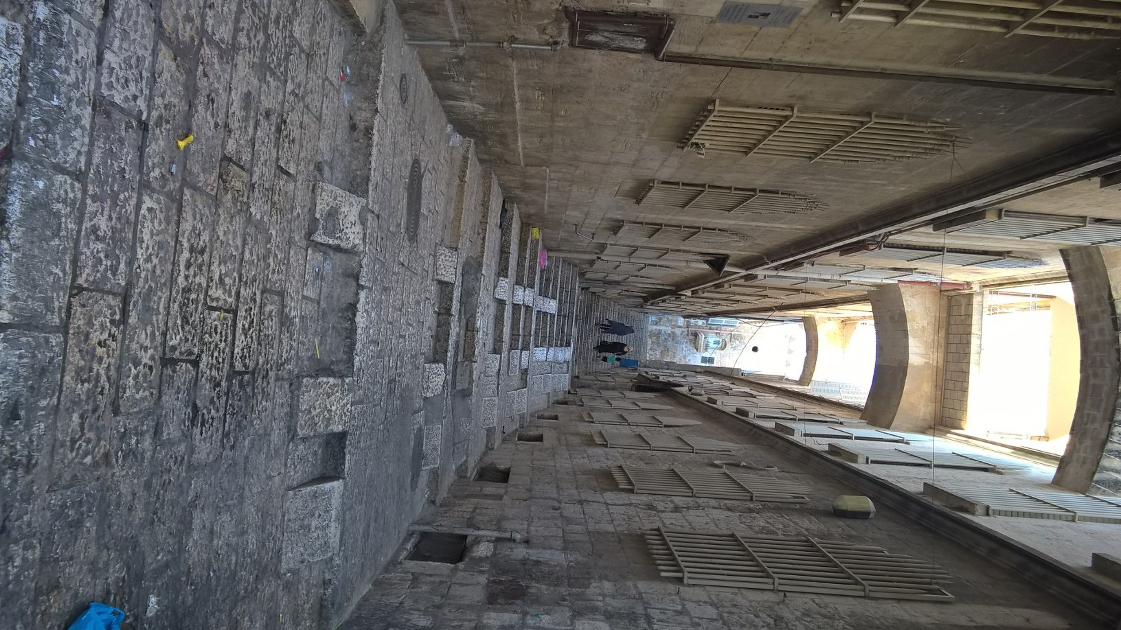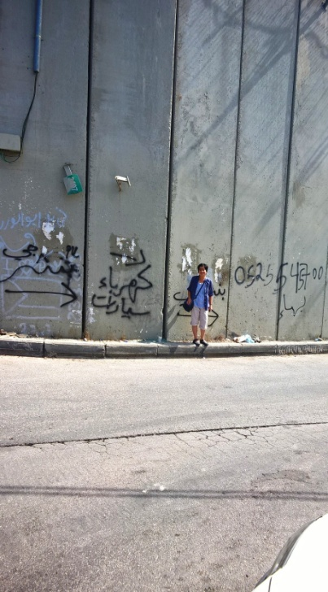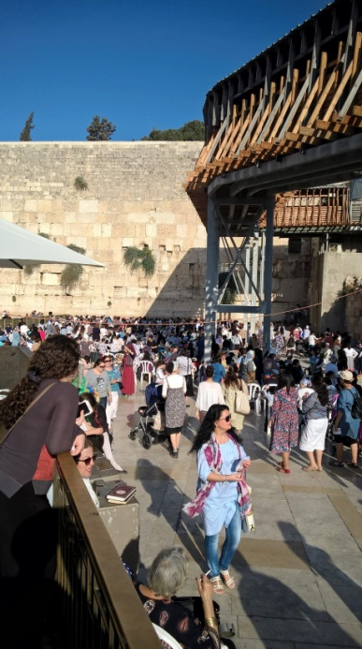
Palestine
Having got through the wall by bus, our first destination was Ramallah, effectively the capital city of Palestine and where the Palestinian Authority has its offices. It is a thriving market town, in which young Palestinians speed about on scooters in headscarves and jeans. Palestine is 70% Muslim and 30% Christian. We visited the Friends School and Friends Meeting House in Ramallah and attended Meeting for Worship. We had a talk from Jean Zaru, Quaker peace campaigner and author of ‘Occupied with Non-Violence’, and were shown around the school by the Friend in Residence.
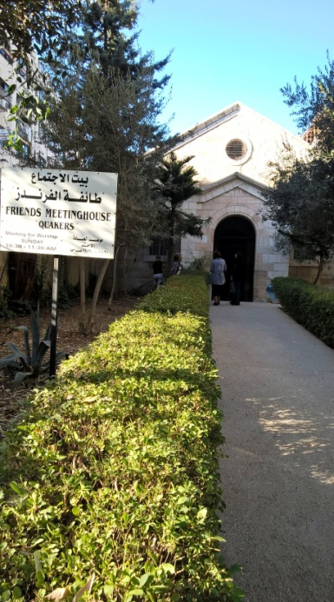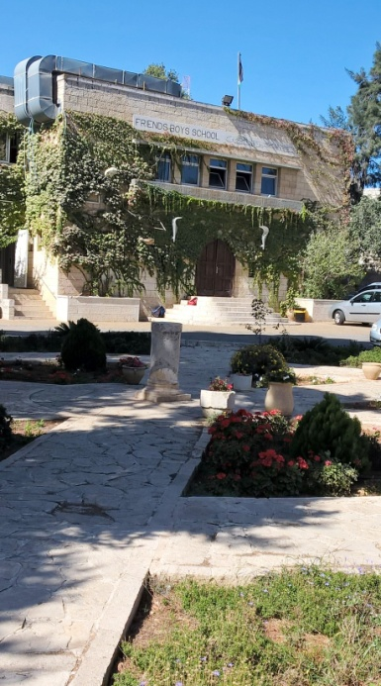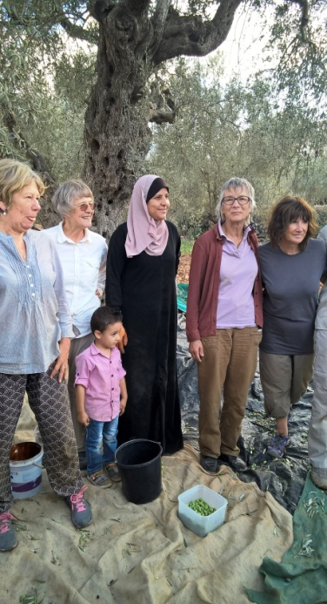
Our guest house in Jifna was the home of a Christian family. It was from there that we had trips out to farms owned by Palestinians on the edge of the Israeli settlements, to help with olive picking. Without ‘internationals’ visiting, the farmers are subject to intimidation and harassment. We also visited Tent of Nations (an internationally renowned peace project), a local Catholic School and a kibbutz, with inspirational talks from peace workers, an American businessman and a kibbutz dweller.
Tel Aviv
We returned to the Israeli side of the wall and spent the last 3 days in Tel Aviv, a modern, secular city on the Mediterranean.

